Inversion of Lower Triangular Matrix F

For a lower triangular matrix F, the inversion is computed iteratively by using equation:

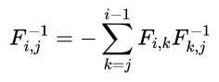

For example, if we consider four iteration then for each iteration *i*, only the elements F ij−1 are calculated with j ∈ [1, *i* − 1] and *i* > 1

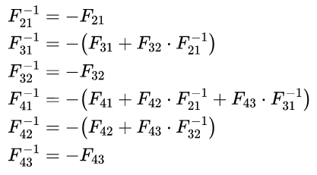

From the above equation it is evident that, at the current iteration, elements of F ij−1 are calculated using the results of the previously computed iterations.